Exercise 2: Implementing the Factory Method Pattern

Document.java:

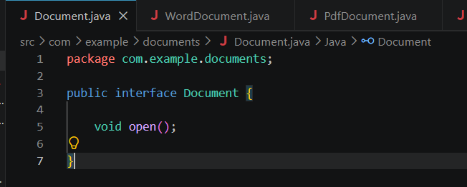

ExcelDocument.java:

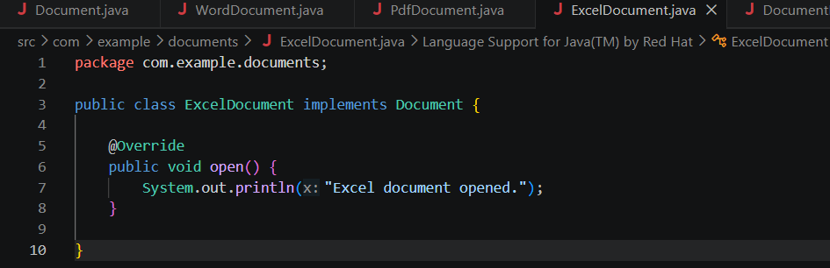

PdfDocument.java:

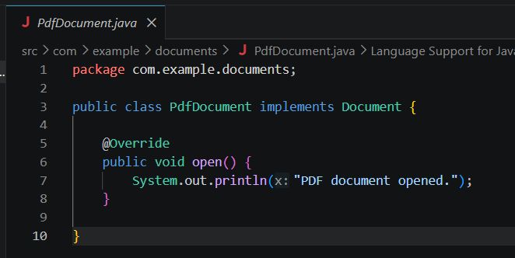

WordDocument.java:

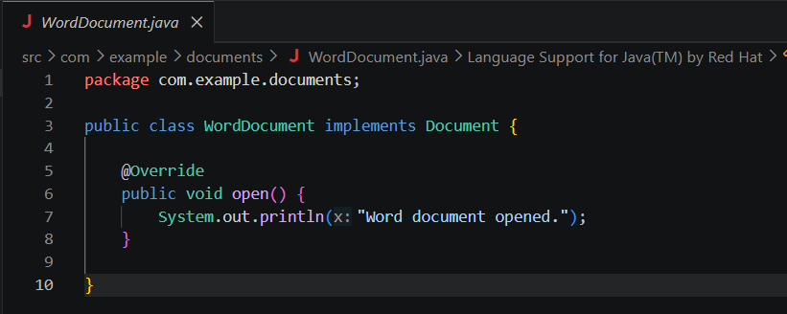

DocumentFactory.java:

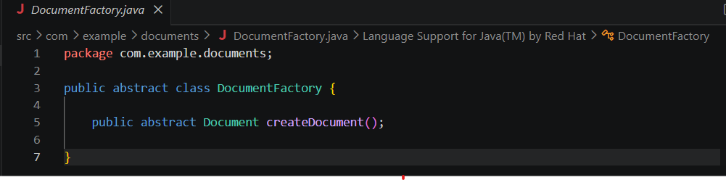

ExcelFactory.java:

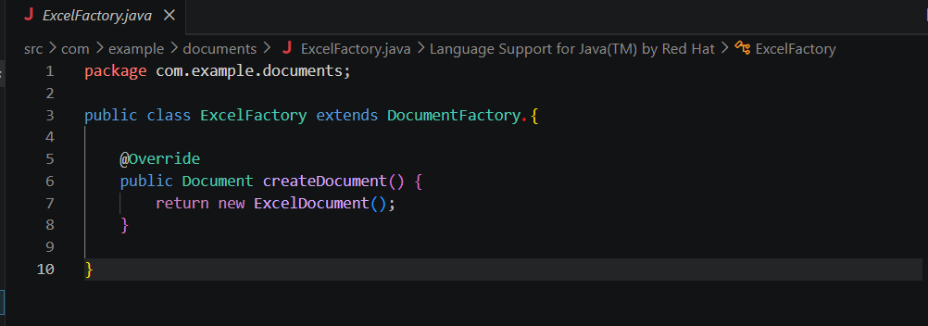

PdfFactory.java:

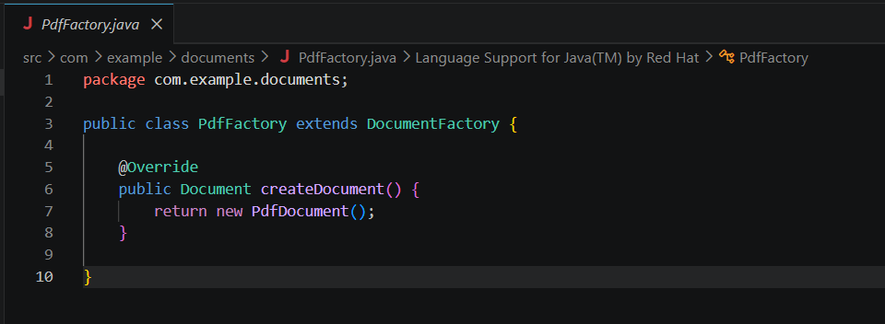

WordFactory.java:

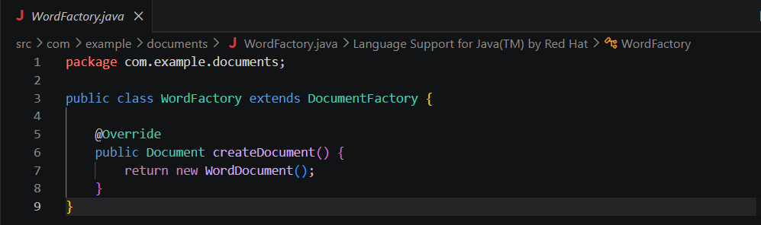

Main.java:

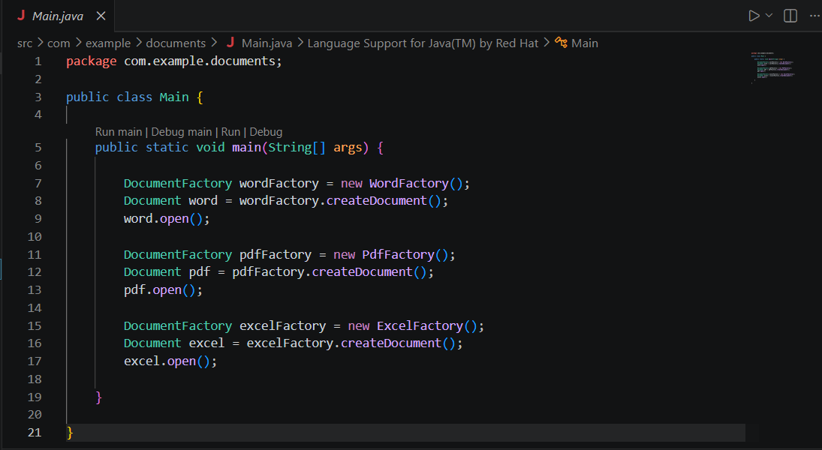

Output:

